┘ ┴ ┴ ┴ ┴ └
┐ ┬ ┬ ┬ ┬ ┌
FRONT

Green Night
at the Morgantown Public Library

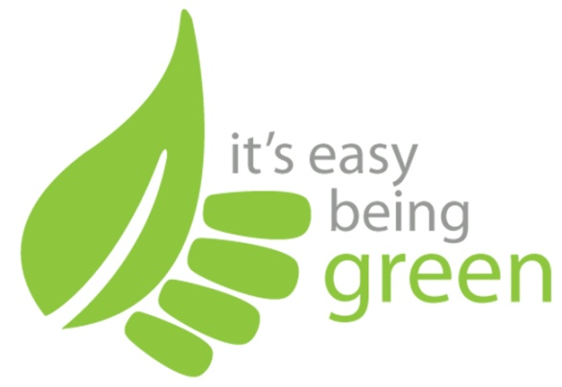

Presented by:
The Morgantown Green Team
morgantowngreenteam.org

February’s Topic:

Green and Clean:
Making Your Own Household Cleaners from
Everyday Ingredients

Name
123 Main St.
Clemson, SC
555-0180
“Slogan or quotation about books or reading”
BACK
┐ ┬ ┬ ┬ ┬ ┌
┘ ┴ ┴ ┴ ┴ └
Green Cleaning
Reference Guide

Books:

Green Housekeeping
by Ellen Sandbeck.

Green-Up Your Cleanup
by Jill Potvin Schoff

Natural Alternatives for You and Your Home: 175 Recipes to Make Eco-Friendly Products
by Casey Kellar

Healthy Child, Healthy World: Creating a Cleaner, Greener, Safer Home
by Christopher Gavigan

Websites:

http://www.thegreenguide.com/home-garden/cleaning/diy-cleaners

http://planetgreen.discovery.com/go-green/green-cleaning/

http://www.circleoflife.org/education/sustainable/greening/green_cleaning.pdf

